SEVENTH-DAY ADVENTIST CHURCH (DIVISION SERVICES) LIMITED

Workstation Ergonomics Self-Assessment Form

The Workstation Ergonomics Self-Assessment is best undertaken by two people e.g. with your manager or Senior Safety Advisor. Work through each item and adjust your workstation to meet the recommended posture. If you answer “No” to any question, discuss this with your manager to review and implement the suggested actions.

Persons Completing Assessment Date of Assessment:_________________

Name: | Position:
Assisted by: | Position:

Item | The Office Chair | Yes/ No/ N/A | Suggested Actions | Comments/Actions Implemented
1 | Can the height, seat and back of the chair be adjusted to achieve the posture outlined below? |  | - Obtain a fully adjustable chair
2 | Are your feet fully supported by the floor when you are seated? |  | - Lower the chair  - Use a footrest
3 | Does your chair provide support for your lower back? |  | - Adjust chair back  - Obtain proper chair  - Obtain lumbar roll
4 | When your back is supported, are you able to sit without feeling pressure from the chair seat on the back of your knees? |  | - Adjust seat pan  - Add a back support
5 | Do your armrests allow you to get close to your workstation? |  | - Adjust armrests  - Remove armrests
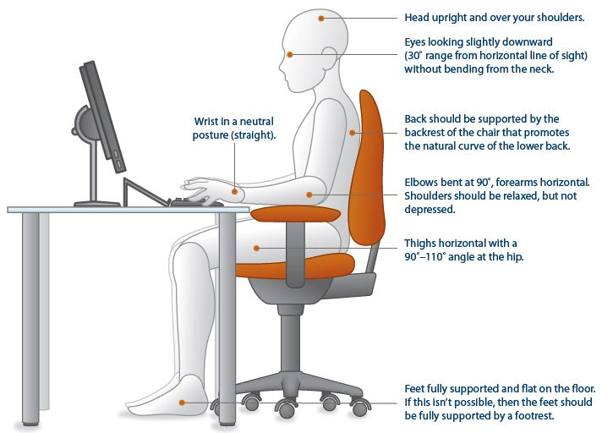

Item | Keyboard and Mouse | Yes/ No/ N/A | Suggested Actions | Comments/Actions Implemented
6 | Is your keyboard, mouse and work surface at your elbow height? |  | - Raise / lower workstation  - Raise or lower keyboard  - Raise or lower chair
7 | Is the keyboard close to the front edge of the desk allowing space for the wrist to rest on the desk surface? |  | - Move keyboard to correct position
8 | When using your keyboard and mouse, are your wrists straight and your upper arms relaxed? The keyboard should be flat and not propped up on keyboard legs as an angled keyboard may place the wrist in an awkward posture when keying. |  | - Re-check chair, raise or lower as needed  - Check posture  - Check keyboard and mouse height
9 | Is your mouse at the same level and as close as possible to your keyboard? |  | - Move mouse closer to keyboard
10 | Is the mouse comfortable to use? |  | - Rest your dominant hand by using the mouse with your non-dominant hand for brief periods (mouse buttons can be changed within the computer control panel)  - Investigate alternate mouse options

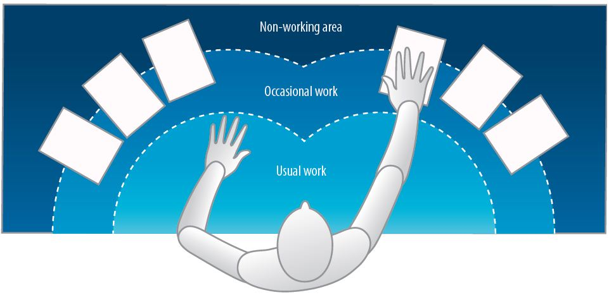

Item | Work Surface | Yes/ No/ N/A | Suggested Actions | Comments/Actions Implemented
11 | Is your monitor positioned directly in front of you? |  | - Reposition monitor
12 | Is your monitor positioned at least an arm’s length away?  Note: the monitor’s location is dependent on the size of the monitor, the font, screen resolution and the individual user e.g. vision/use of bifocal spectacles etc. |  | - Reposition monitor
13 | Is your monitor height slightly below eye level? |  | - Add or remove monitor stand  - Adjust monitor height
14 | Is your monitor and work surface free from glare? |  | - Windows at side of monitor  - Adjust overhead lighting  - Cover windows  - Obtain antiglare screen
15 | Do you have appropriate light for reading or writing documents? |  | - Obtain desk lamp  - Place on left if right-handed  - Place on right if left handed
16 | Are frequently used items located within the usual work area and items which are only used occasionally in the occasional work area? |  | - Rearrange workstation

Item | Breaks | Yes/ No/ N/A | Suggested Actions | Comments/Actions Implemented
17 | Do you take postural breaks every 30 minutes? E.g. standing, walking to printer / fax etc.? |  | - Set reminders to take breaks
18 | Do you take regular eye breaks from looking at your monitor? |  | - Refocus on picture on wall every 30 minutes

Item | Accessories | Yes/ No/ N/A | Suggested Actions | Comments/Actions Implemented
19 | Is there sufficient room for reading and writing tasks if required? |  | - When reading or writing, lower chair to bring eyes closer to the desk surface and improve posture
20 | Is there a document holder either beside the screen or between the screen and keyboard if required? |  | - Obtain document holder
21 | Are you using a headset or speakerphone if you are writing or keying while talking on the phone? |  | - Obtain a headset if using the phone and keyboard

Item | Laptop | Yes/ No/ N/A | Suggested Actions | Comments/Actions Implemented
22 | In the event of using a laptop computer for prolonged periods of time, do you use:  - A full sized external keyboard and mouse;  - Docking station with full sized monitor or a laptop stand |  | - Obtain appropriate laptop accessories

Item | “Hot Desking” (when applicable) | Yes/ No/ N/A | Suggested Actions | Comments/Actions Implemented
23 | Provided time, support and supervision to make above adjustments. |  | - Adjust workstation at each hot desk

Manager to complete

Name: |  | Position:
Signature: |  | Date:
Comments | E.g. New ergonomic chair approved  E.g. Formal ergonomic assessment approved

Manager to maintain completed assessments.

